Editing Music and Sound Using Audacity
Find sound or music that you want to include in your animation.
You may look at the websites below for things to download.
Right click on the sound you want, and go down to save link or save target as wav or mp3.
Music & Sound Website
http://www.wavsource.com/ - movie, tv & game quotes
- Go to https://www.youtube.com/ and type in the name of your song.
- Copy the address of your song
- Go to https://www.ytmp3.net/ and paste the youtube address
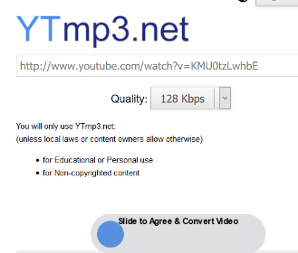
- Slide to agree.
- When it is finished converting, click download, make sure it has mp3 as they type!
- Give it a short name and SAVE.
**********************************************
After you have downloaded your songs, search for Audacity and open it.
Go to File & Open and load your song.
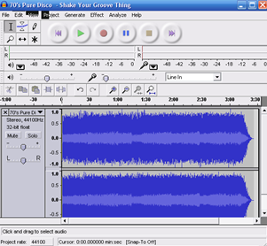
Original Song
Use headphones/earbuds to listen to your music.
Highlight the 10-30 second section of your song that you want to save. Make sure that the sound is not playing, when you export. Give it a short song name.
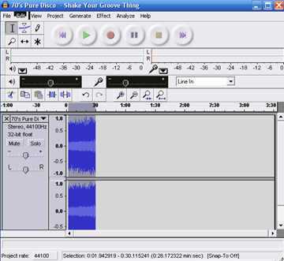

EXPORT SELECTION AS WAV to save your song part.
DO NOT SAVE, EXPORT!!!!
If you get an error message that says you need Lame, raise your hand, and I will install Lame for you.
- If you want to edit out parts or words, highlight the part you want to delete, stop the play, and hit the delete key.
- If you want to combine parts of different songs:
  - export the parts you want separately or copy and paste.
  - Open one of the song parts, go to File and Import and import the other song part.
  - You may then copy and paste them together.

.WAV in Visual Basic
- Double click on My Project in the Solution Explorer window.
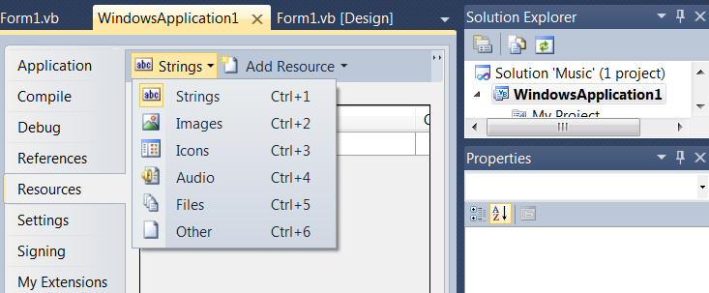
- When it opens the new tab, click Resources.

- You will see the word Strings. Click on the down arrow next to Strings and select Images for pictures or Audio for songs.

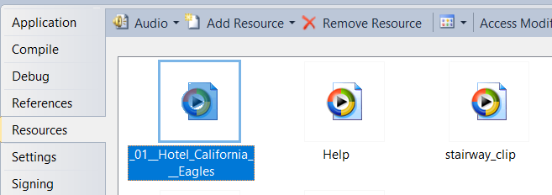
- Open the Music or Downloads folder and drag the music you want to the open space in VB. The items you dragged will appear under the Resources folder in the Solution Explorer.

  - When you enter the dot after Resources, a dropdown menu of the items in the resources folder will appear. Choose the one you want.

- Under the code for each radio button enter the following code:
- My.Computer.Audio.Play(My.Resources.Hotel_California_Eagles, AudioPlayMode.Background)

